**COVID-19**

**Policy and Response Plan**

**June 2020**

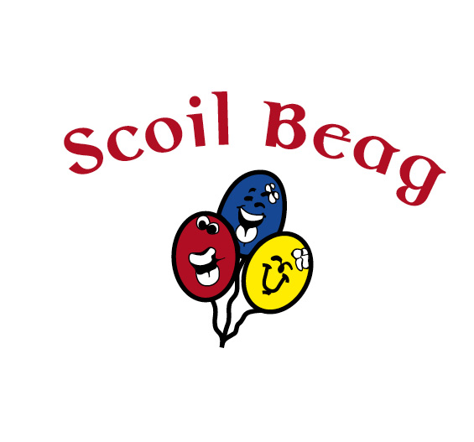

**CONTENTS:**

**Introduction**

**This Policy and Response Plan**

**Policy Statement**

**1. Notification to Tusla**

**2. Covid-19 Infection Control Policy**

* Symptoms
* How it is transmitted or spread
* How to reduce the risk of transmission
  + Hand Hygiene
  + Personal Protective Equipment (PPE)
  + Face Masks
  + Social distancing
* Specific measures to reduce the risk of transmission of COVID-19 in our setting
* Play pods
* Staff’s physical contact with children
* Physical environment
* Toys and equipment
* Trips
* Food provision
* Sleep/rest
* Children’s personal care
* Enhanced COVID-19 cleaning schedules
* Fire evacuation
* Parents
  + Revised drop off and collection procedures
  + Communication with parents/guardians
* Actions to prevent adults and children with symptoms of COVID-19 from entering the service
* Staff: Health and Safety Authority return to work protocol
* Staff: After returning to work
* Children: Child return to Service
* Children: After returning to the Service
* Parents
* Visitors and Contractors
* The incident plan where a child or staff member has or is suspected of having COVID-19 while attending the service
* Temperature testing
* COVID-19 testing
* Vaccination

**3. Covid-19 Enhanced Risk Management Policy**

* Risk management and COVID-19
* Fire safety
* Cleaning between sessions
* Daily Risk Assessment
* Some of the areas of risk that will be included in the risk management process:
  + People
  + Activities
  + Environmental

**4. Staffing**

* Rosters
* COVID-19 staff induction training
* COVID-19 lead staff representative
* Staff breaks
* Meetings
* Staff clothing
* On-going communication and support

**Cleaning Facilities Availability Within Our Service**

**COVID-19 Policy and Response Plan Scoil Beag**

|  |  |
| --- | --- |
| **Name of the Service:** | **Scoil Beag** |
| **Document Title:** | **Covid-19 Policy and Response Plan** |
| **Document Author:** | **Canavan Byrne** |
| **Document Approved by:** | **Manager: Nicola Kindlon**  **Updated by Acting Manager: Shauna Hanlon on 18/09/2020** |
| **Person(s) responsible for developing, distributing, implementing and reviewing Policy:** | **Persons responsible:**  **Nicola Kindlon**  **Shauna Hanlon** |
| **Person responsible for approving Policy:** | **Approved by: Nicola Kindlon**  **Shauna Hanlon** |
| **Method of communication of Policy to staff (e.g. email, hard copy, induction training, sign off):** | **Induction Training** |
| **COVID-19 Lead Staff Representatives** | **Shauna Hanlon and Danielle Groome** |
| **Method of communication of Policies to parents/guardians (e.g. via email, hard copy displayed in service):** | **Email and Displayed in Service** |
| **Method of communication of Policies to children (e.g. posters, games, discussion, role modelling):** | **Posters & Discussions** |
| **Method of communication of Policies to Stakeholders (e.g. full policies via email, hard copy):** | **Email** |
| **Date the Document is Effective From:** | **29/06/2020 Updated 18/09/2020** |

**COVID-19 Policy and Response Plan**

**Service Name: Scoil Beag**

**Introduction**

The government has published a ‘Return to Work Safely Protocol, COVID-19 Specific National Protocol for Employers and Workers[1]’ which describes the measures required to be put in place by employers and adhered to by workers to reduce the risk of the spread of COVID-19 in the workplace as it re-opens on a phased basis under the government’s roadmap. The Health and Safety Authority (HSA) has been given the authority to oversee compliance with the protocol. Early Childhood Ireland (ECI) has issued a setting preparation plan detailing the policies and practices necessary for providers to meet the requirements under the National Protocol.

The Department of Children and Youth Affairs (DCYA), HSE, HPSC and Tusla have issued guidance for the reopening of early learning and care and school-age childcare services during the COVID-19 pandemic.

The National Protocol and guidance for the sector incorporates current advice about measures to reduce the spread of COVID-19 in the community issued by the National Public Health Emergency Team (NPHET) but as this advice evolves these measures and guidance may change so it is very important for providers to keep up to date with any new advice.

**This policy and response plan**

* Is informed by the Government’s Return to Work Safely Protocol, COVID-19 Specific National Protocol for Employers and Workers.
* Is underpinned by the government’s key recommendations to reduce the risk of transmission of the coronavirus: good hand hygiene, good respiratory hygiene, social distancing and regular cleaning and disinfecting.
* Is informed by the Department of Children and Youth Affairs (DCYA), HSE, Tusla, Early Childhood Ireland (ECI) and HPSC COVID-19 guidance for the early years sector[2]
* Principles underpinning practice when reopening early learning and care and school-age childcare services during COVID-19
* COVID-19 Infection Prevention and Control guidance for settings providing childcare during the COVID-19 pandemic.
* Tusla Guidance Document for Early Years Services: COVID-19
* Tusla Early Years Services: Self-Assessment Checklist
* Is in addition and complimentary to Regulation 23 Safeguarding, Health, Safety and Welfare of the Child of the Child Care Act 1991 ~~(~~Early Years Services Regulations) 2016
* Is in addition to the Services’ Infection Control Policy
* Is in addition to the Services’ Risk Management Policy
* Is in addition to the Services’ Staff Training Policy
* Is in addition to the Services’ Dropping Off and Collection of Children Policy

**Policy Statement**

This policy is intended to support Scoil Beag to safely re-open our services for staff, parents and children, to adopt a risk assessment approach and to implement public health measures to reduce the risk of the transmission of COVID–19 so as to provide a safe and healthy environment.

This policy sets out procedures to implement public health measures to reduce the risk of the transmission of COVID-19 while ensuring that the service’s policies and practices remain child-centered and that children’s health and well-being are a primary concern.

The service has a strong focus on the importance of effective communication with staff, parents and children and supports that may be required to alleviate the impact of the disruption, uncertainty and distress for some caused by COVID-19

1. **Notification to Tusla**

COVID-19 is a notifiable disease and must be notified within 3 working days of the Service becoming aware of a notifiable incident. Tusla have developed a Notification Form for COVID-19 which includes additional information regarding the risk of closure as a result of COVID-19. The purpose of this form is to monitor any pending COVID-19 public health issue in early years settings and the continuation of childcare provision.

We will use this form in the event of an outbreak.

1. **Covid-19 Infection Control Policy**

The Service’s Infection Control Policy has been reviewed in the light of the COVID-19 pandemic and in accordance with HPSC and Tusla’s Early Years Inspectorate Guidance and Information on how to plan for re-opening and operating as safely as possible at this time. What is set out below is the additional enhanced procedures and should be read in conjunction with the service’s standard policy.

Covid-19 is a new illness caused by a new coronavirus (SARA-CoV-2) which is spread mainly through tiny droplets scattered from the mouth or nose of a person with the infection. The droplets can be scattered when the infected person coughs, sneezes, talks or laughs. To infect you, it has to get from an infected person's nose or mouth into your eyes, nose or mouth.

Anyone can get this illness but to date the evidence is that older people and those in at risk categories are most seriously affected.

**The most common symptoms are:**

* Cough - this can be any kind of cough, usually dry but not always
* Fever - high temperature over 38 degrees Celsius
* Shortness of Breath
* Breathing Difficulties

It can take up to 14 days for symptoms to appear. Some cases are asymptomatic, meaning there are no symptoms, however the individual is still infected with Covid-19.

**Children**

The current evidence suggests that children seem generally less likely to contract the virus and are not more likely than adults to spread the virus to other people. Children can get this illness but the current evidence is that they have no symptoms or a very mild disease.

**Symptoms in children include:**

* Cough
* Fever
* Runny nose
* Sore throat
* Diarrhea
* Vomiting

**How it is transmitted or spread**

* COVID-19 is transmitted in breath, sneeze or cough droplets
* The virus is transmitted through bodily fluids from an infected person's nose or mouth coming in contact with your eyes, nose or mouth.
* Transmission can be directly from person to person, however it is more commonly transmitted indirectly, when you touch surfaces or objects where the virus is present, followed by touching your face, where the virus enters through the mucous membranes
* Children are not more likely than adults to spread the virus

**How to reduce the risk of transmission**

**Hand hygiene[3]**

**We will follow the following protocol in terms of hand washing**

**We will wash our hands frequently**with soap and water or use an alcohol-based hand rub if hands are not visibly dirty for 40-60 seconds and in line with the WHO and HSE recommendations

* The service will promote good hand hygiene techniques in line with HSE and WHO guidelines, and support children to do the same through modelling, signage, activities and games
* We will ensure an adequate supply of liquid soap, hand gel or rub and disposable or paper towels available throughout the premises including the arrival and outdoor areas. All hand gels and rubs must be kept out of children’s reach.
* All hand gels for staff, parents or visitors to the Service are alcohol based.
* It is better if children wash their hands where possible and we will aim for children to wash their hands in our service but where this is not possible hand gels being used by children will be supervised by staff.
* We will use liquid soap and warm running water for hand washing and only use hand gels or rubs where running water is not available
* Hand gel or rub must be applied vigorously over all hand surfaces, for 40-60 seconds, and are only effective if hands are not visibly dirty.
* If hands are physically dirty, then they need to be washed with liquid soap and warm water and children and staff will have to go to the nearest sink or bathroom.
* Staff and children will be encouraged to avoid touching their eyes, their mouth or nose with their hands

1. **How to wash your hands with soap and water (HSE)**

* Wet your hands with warm water and apply soap.
* Rub your hands together until the soap forms a lather.
* Rub the top of your hands, between your fingers and under your fingernails.
* Do this for about 20 seconds.
* Rinse your hands under running water.
* Dry your hands with a clean towel or paper towel.

1. **Children should wash their hands and be supervised doing so**

* When they arrive at the Service and before they go home
* Before eating and drinking
* After a nappy change or using the toilet
* After playing outside
* After sneezing or coughing into their hands
* Whenever hands are visibly dirty

1. **Staff should wash their hands**

* When they arrive at the Service and before they go home
* After coughing and sneezing
* Before handling food, or feeding children
* Between handling raw and cooked food (kitchen staff)
* Before and after eating their own food – breaks/lunches
* Before and after giving or applying medication or ointment to a child
* After changing nappies, assisting a child to use the toilet or using the toilet themselves
* After caring for babies or children who are teething or dribbling.
* After caring for babies and young children who require close physical contact and comfort, where contact points such as the neck or arms may become contaminated with secretions or mucous, these should be washed immediately.
* If staff move from one room to another room or from inside to outside areas
* If staff have physical contact with a child from another group other than their own group
* After contact with bodily fluids (runny nose, spit, vomit, blood, faeces)
* After cleaning tasks
* After removing gloves
* After handling rubbish
* Whenever hands are visibly dirty
* If in contact with someone who is displaying any COVID-19 symptoms
* Before and after being on public transport [if using it]
* Before and after being in a crowd
* Before having a cigarette or vaping [staff are reminded the service is a non-smoking area]



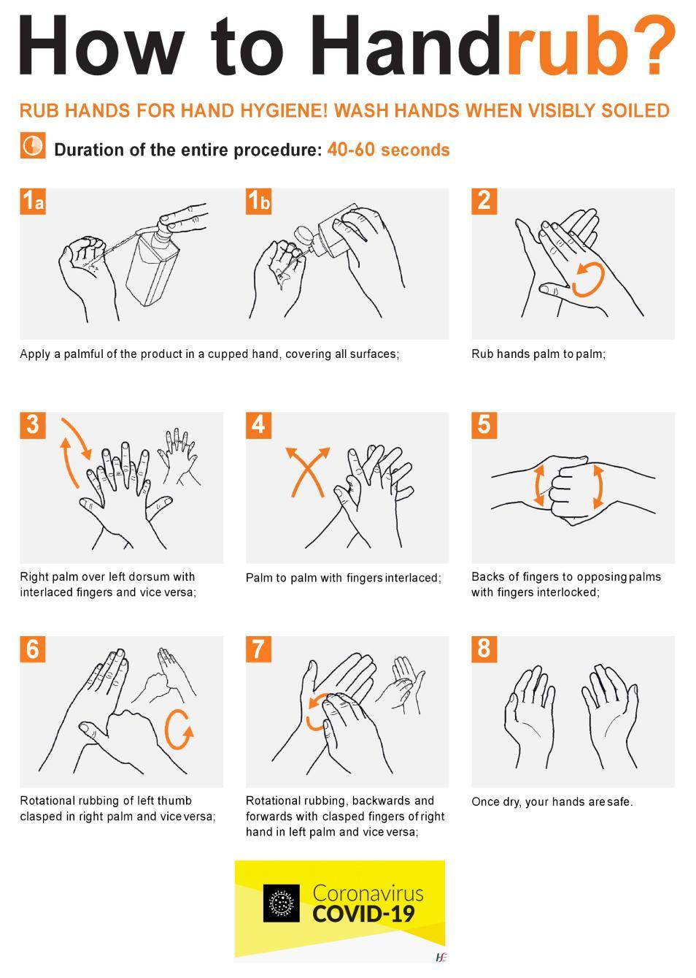

**Respiratory hygiene practice, good respiratory hygiene**, that is, when coughing and sneezing, cover your mouth and nose with flexed elbow or tissue – discard tissue immediately into a closed bin and clean your hands with alcohol-based hand rub (for adults) and alcohol-free rub for children or soap and water for 40-60 seconds and in line with the WHO and HSE recommendations.

* Staff and children must adopt good respiratory hygiene and etiquette
* Cough or sneeze into your elbow or into a tissue
* The Service ensures that tissues are readily accessible throughout the Service with a dedicated pedal operated bin provided in each of the rooms and in the outdoor areas for easy disposal of used tissues.
* Staff and children should wash their hands after coughing or sneezing

**Avoid touching your eyes, nose and mouth** – the virus enters the body through eyes, nose and mouth so refraining from touching your face drastically reduces the chances of contracting the virus.

**Personal Protective Equipment (PPE)**

The service will have an adequate supply of PPE for use when required by staff including visors, disposable single use plastic aprons and non-powdered, non-permeable gloves e.g. when there is a risk of coming in contact with bodily fluids.

**Face Masks**

The government has advised wearing a face mask in public indoor spaces where social distancing is difficult to maintain e.g. public transport, retail outlets. The public health advice is that the wearing of face masks by children under 13 years of age is not recommended and there is no requirement by others to wear masks in the childcare environment. Staff have been given visors by the service; however, this is personal preference for staff if they would prefer to wear the visor or not while in their own pod. That being said, if there is a need for a staff member to enter another pod, they will need to wear a visor and PPE gear. Some specific tasks and roles may require the use of masks e.g. administering some First Aid, caring for a staff member or child who presents with symptoms of COVID-19 while at the service, cleaning.

**Social distancing**

* **Maintain social or physical distancing**, that is, leave at least 2 metres (6 feet) distance between adults when staff are not engaged in childcare activity e.g. breaks or arriving at work
* As part of social distancing a ‘**no handshaking policy’** will be implemented
* The service recognises that it is not possible for staff to observe physical distancing when caring for young children and it is not practical nor recommended that young children should physically distance from each other in their play pod

**Specific measures to reduce the risk of transmission of COVID-19 in our setting**

1. **Play pods**

* Where possible the service will implement the DCYA recommendation to organise children and staff into ‘play pods’ which comprise of a group of children and staff, who remain with that group of children as keyworkers each day and throughout the day as far as possible. The purpose of the ‘play pods’ is to limit the number of people a child and a staff member have contact with, to facilitate contact tracing and to support close, positive interactions between children and their adult caregivers.
* The service will determine the maximum size of the play pod. The department has advised that there is no evidence on which to define a maximum pod size but that they should be kept as small as is likely to be reasonably practical in the specific childcare context. Pod sizes may take account of regulations relating to maximum adult-child ratios for the different age groups.
* The department has also advised that there will no change to the adult-child ratios and space requirements for the different age groups and care categories under the Child Care Act 1991 (Early Years Services) Regulations 2016
* As far as possible, there will be no contact between two or more play pods (children and staff). Play pods will remain apart in separate or shared spaces including outdoors and at dropping off and picking up times. This will help to ensure that in the case of a confirmed Covid-19 case, only one play pod is affected and the service can still continue following disinfection, cleaning etc. Any decisions to close any part of the service will **only** be made in consultation with local public health staff.
* In as far as practical, the service will structure the play pods to have the same adults in the pod, We will try to reduce the need for other adults to enter the pod.
* Within a play pod social distancing between young children under the age of 6 is not recommended and, therefore, we will not expect children to social distance in our Service.
* After School children from Scoil Phadraig Naofa will only attend our After School service. Junior and Senior Infants will be in the same pod in our service. After school for 1st- 3rd class has been suspended for the moment.
* In the event that a staff member has to move between play pods e.g. to cover for staff absences/breaks staff must wash wear a visor and wash their hands on entry and leaving a play pod and a record should be kept of this movement and should be kept to an **absolute minimum.**
* The service will manage the circulation and movement of children in their play pod between their room, the toilets, the outdoor area and any other areas of the service so as to ensure no physical contact with children or staff in other play pods in as far as possible
* The service will use markings on the ground and other ways to divide indoor and outdoor physical areas so as to support and guide children’s safe movement within their ‘play pods’ and reduce contact with children in other groups.
* **A record will be retained of the people (children and carers) in each pod on each day to facilitate contact tracing** in the event of an episode of the infection
* The formation of pods is less relevant or not relevant in settings caring for smaller numbers of children.

1. **Staff’s physical contact with children**

* The service requires staff in the same play pod to implement social distancing of 2 meters or 6 feet between them while they are working with children in as far as possible, whilst ensuring children are kept safe and well cared for.
* The service recognises that babies and young children need physical contact and comfort from staff for their safety, their wellbeing and to attend to their personal care needs and that staff will have close contact with children in their play pod.
* The service recommends that children should initiate the physical contact with staff or where children are indicating through their behaviour or words that they need comfort, that staff respond to the children’s needs for physical comfort, nurturing or hugs
* The service recommends that staff do not kiss children.
* Staff should be cognisant of any dribbling or mucus discharge when holding babies and to wash their hands and change clothes.

1. **Physical environment**

* The premises will be cleaned thoroughly both indoor and outdoor prior to the service re-opening, including all toys and equipment
* Each room at Scoil Beag will be open at 8am-5pm to ensure each child safe entry to their play pod.
* The service will ventilate the environment as much as possible and within temperature requirements e.g. through opening windows in advance of children being in the room or while they are outside. COVID-19 thrives more in an indoor environment.
* The service will use the outdoor space as much as possible when the weather permits. This increases the space for activities to be set up and increases the space between children.
* Child friendly signage will be displayed including physical distance markings in communal areas and at drop and collection points to encourage social distancing and to prevent groups congregating
* We have placed a notice (available in a language that is easily understood by parents/guardians of the children attending) at the entrance to the service stating that children and staff may not attend if a child/parent/household member or staff member has
* signs or symptoms of respiratory infection, such as a cough, shortness of breath and/or fever
* temperature of 38C or over
* Children’s personal items (e.g. clothing and bags) will be separately stored for each child Can each parent send in coats/clothing inside a zipped ‘’school bag’’ and all items will remain in personal/individual bags at all times unless items in use ie; coats for outside.

**Physical environment – staff areas**

* Offices should be treated like childcare rooms and access limited primarily to office staff and when childcare staff have to complete administrative, filing or reporting tasks
* Office spaces should be reconfigured to ensure social distancing of 2 meters or 6 feet between the staff. Where that can’t be organised only one staff member should use the office at a time
* Where it is difficult to organise staff spaces to facilitate social distancing, physical partitions to reduce the transmission of the coronavirus between staff may need to be considered
* Where staff share a desk or hot desk, surfaces that are regularly touched should be cleaned after each staff member has used the space e.g. keyboard, mouse, desk, chair, press
* Staff should not share equipment such as pens, cups and plates but should have these items for their own personal use.
* Where a staff room is used ensure tables and chairs are placed far enough apart to ensure social distancing of 2 meters
* Staff are responsible for cleaning and disinfecting their tables and chairs after use for the next person.
* Cutlery and crockery should be washed in a dishwasher at 60°. All staff to take their own utensils for break/Lunch.

1. **Toys and equipment**

* The service will organise toys and play materials into a number of boxes for the different groups or ‘play pods’ of children and wash the toys after use each day. In this way each group or play pod of children has its own box of toys and there is no sharing across play pods.
* The service will offer toys that can be easily cleaned, disinfected (where necessary) and dried on a daily basis
* The service will consider carefully the use of certain toys that are difficult to clean e.g. dress up clothes, soft toys. These will be removed from the service on a temporary basis during this Covid-19 emergency and will be reviewed at a later stage.
* The service will limit the use of playdough, gloop and similar materials, and where being used should not be shared between the children and should be replaced daily
* The service will limit food preparation activities (on a temporary basis during this Covid-19 emergency) where children take turns in preparing and later eating the food
* Toys, jigsaws and puzzles used by babies and young children, which have been placed in their mouths, will need to be capable of being washed before reuse by another child in their play pod.
* The service will offer sand and water play for the children in their play pods e.g. in their rooms, but must not be shared across the play pod
* The service will ask parents and children not to bring soothers, comforters or favourite toys from home into the centre. If a child needs a soother the parent is asked to bring in a new soother which will be retained in the service.
* The Service will be responsible for sterilising soothers, teething rings and other comfort items left on the premises. These items should not be brought in every day to the Service. They are either retained in the Service or supplied by us.

1. **Trips**

The Service does not go on outings.

1. **Food provision**

* Ancillary/catering staff should not be moving between rooms. Food should be brought to the individual care rooms and served by the staff members working in the ‘play pod’ in the room**.**
* Children will have their snacks and meals with children in their play pod in their room.
* The service actively discourages the sharing of food between children and between staff.
* Children and staff are not permitted to bring lunch boxes into the service. Dinners /snacks are provided but if snacks are a must from home should be provided for children wrapped in a zip lock plastic bag clearly marked with a child’s name. Staff should also bring their lunches in zip locked bags

1. **Sleep/rest**

.

* Sleeping cots will be arranged as normal so that there is a physical distance of 50 cm between cots. Sleeping cots will be arranged so that there is physical distance of 2 meters between groups of cots for children from different pods
* Cots ideally should not be used by more than one child, and it is preferable that each child requiring a cot would have their own named cot or sleep bed/mat and own named bed linen
* Where children cannot be provided with their own named cot, children can use the same cot at different times subject to strict infection control practices being undertaken between use
* Cleaning of the cot frame
* Cleaning of the mattress
* Changing of the bed linen
* Labelling of the sleep equipment with the name(s) of the children who use the cot
* Daily cleaning of mattresses and sleep mats must take place with additional cleaning required when visibly soiled.
* The provision of individual sheets and bed linen is required, and staff must be vigilant in the safe removal and laundering of soiled linen and the appropriate storage of clean bed linen.
* All laundry is to be washed at the highest temperature that the fabric can tolerate. See <http://www.hpsc.ie/>.
* Child-sized furniture used in cosy corners must be easy to clean and covered in a wipeable material.

1. **Children’s personal care**

* The service uses the following procedure: when providing personal care to babies such as nappy changing or supporting toddlers with toileting: staff should wear disposable single use plastic aprons and non-powdered, non-permeable gloves as well as washing hands before and after use of gloves

1. **Enhanced COVID-19 Cleaning Schedules**

We will use enhanced cleaning schedules which specify:

* The areas to be cleaned, particularly frequently touched surfaces, e.g. light switches, door handles, taps, toilet flush handles, tables
* The method of cleaning, frequency of cleaning, and the cleaning product to be used
* All toys, in particular mouthed toys, and also outdoor toys and equipment
* A procedure for cleaning and storage of soothers, Sippy cups, and oral sensory chewing devices
* Each care room or pod (where there is more than one pod per room) will have an adequate supply of cleaning agents stored safely so that staff do not have to leave the care room to retrieve them. The provider will ensure that there are adequate supplies of cleaning agents, liquid soap, hand gel/rub, paper hand towel

**Cleaning of Toys**

* All toys (including those not currently in use) will be cleaned on a regular basis, i.e. weekly. This will remove dust and dirt that can harbour germs.
* Toys that are used by very young children will be washed daily.
* Toys that children put in their mouths will be washed after use or before use by another child.
* All toys that are visibly dirty or contaminated with blood or body fluids must be taken out of use immediately for cleaning or disposal. Toys waiting to be cleaned must be stored separately.

**Cleaning Procedure**

* Wash the toy in warm soapy water, using a brush to get into crevices.
* Rinse the toy in clean water.
* Thoroughly dry the toy.
* Hard plastic toys may be suitable for cleaning in the dishwasher.
* Toys that cannot be immersed in water i.e. electronic or wind up should be wiped with a clean damp cloth and dried.

**Disinfection procedure**

* In some situations, toys/equipment may need to be disinfected following cleaning. For example:
  + Toys/equipment that children will place in their mouths.
  + Toys/equipment that have been soiled with blood or body fluids.

1. **Fire evacuation**

* Fire evacuation will be carried out per room rather than the entire building during the period of COVID-19

**Parents**

**Revised Drop off and Collection Procedures**

The purpose of these dropping off and picking of children procedures is, in as far as possible, to support social distancing and minimize the number of contacts that parents and children have with other parents and children, especially at the entrance to the service or in the arrival area. The service will where practical:

* Ensure that the group of children in their ‘play pod’ and parents are met by the keyworker staff assigned to that ‘play pod’ group of children
* Use 2-meter markings on the ground outside the service to encourage parents with their children to socially distance at drop off and collection times
* Request that only one parent per family drops off and collects their child/children.
* Ask parents to wash their hands and children’s hands at home before they come to the service.
* Ask parents to take their child’s temperature each day before they come to the service as part of ensuring that children are well, this will need to be balanced against not causing distress to the child.
* One staff member will take the children’s temperature on arrival to service and if 38° or over will not be accepted into Scoil Beag. To ensure that queues don’t develop at drop off in the morning two staff members are to bring children to their induvial room after their temperatures are taken. This will mean if parents need to speck directly to the children’s teachers they will need to phone ahead or wait until collection in the evenings to speck to staff from their child’s pod.
* Ask parents to bring their child to the centre in clean clothes each day. Where this is not practical, discuss alternatives with the parents. The service should ensure that it has additional clean clothes for children to change into if required all children to take spare clothes/coats etc in a zipped ‘’school Bag’’.
* Ask parents not to leave equipment such as buggies, car seats, scooters at or in the premises but to bring them home.
* Ask parents on arrival at the service and at collection times, to use the hand sanitizer provided at the entrance.
* Ask parents not to enter the building at drop off or collection times
* Parents ring the bell and await designated staff member to come to the front door
* Limit access to the service to parents of infants and those with specific needs or in risk categories.

**Communication with parents/guardians**

In advance of children returning, the service will make contact with parents:

* To enquire if their child is returning to the service
* To ask them to complete the return to service child form
* To explain the revised COVID-19 health and safety and risk management procedures, the revised drop off and collection procedures, the purpose of these new procedures in reducing the transmission of the virus and that the service is safe for their children to return to while acknowledging that the risk of the virus being transmitted cannot be fully eradicated.
* To explain the ‘play pod’ – who will be their child’s key worker and that the purpose is to reduce the number of close contacts that their child and the staff will have while attending the service
* To emphasise the importance of their child only attending the service if they are well and with no symptoms of COVID-19 and actions to be taken if their child is displaying any of the symptoms of COVID-19 or is a confirmed case or is a close contact with a suspected or confirmed case
* To explain the actions that will be taken if a child or staff member shows symptoms of COVID-19 while attending the service including that their child’s temperature may be taken in this context
* To request an additional emergency contact in the event that they are not contactable
* To explain the parental agreement, what it will cover and that parents will be required to sign it
* To assure them that the service’s practices will continue to be child-centered
* To emphasize the responsibilities of parents in supporting the new procedures.
* The service will also seek to understand if COVID-19 and the restrictions have had any traumatic or difficult impacts on the child and family and how the service may need to support the child on their return.
* The service recognizes that ongoing communication will be really important especially if procedures change or are updated and this helps to make everyone feel secure and safe with the new procedures.
* The service will ensure that parents are met at the entrance of the service each day by a staff member working in the ‘play pod’ that their child is in, while adhering to social distancing between the adults. In addition to the usual communication about children, this time also allows discussion on children’s health and any sign of them being unwell.
* Given that communication between staff and parents will be reduced to drop off and collection times, management and staff will use alternative ways to communicate with parents e.g. email, text, phone.

**Actions to prevent adults and children with symptoms of COVID-19 from entering the service**

**Staff**

**Health and Safety Authority return to work protocol**

* Before returning to work all staff must complete a pre-return to work format least three days in advance of returning to work. This form should seek confirmation that the staff member to the best of their knowledge has no symptoms of COVID-19, that they are not self-isolating, that they are not a close contact of a person who is a confirmed or suspected case of COVID-19 in the past 14 days or awaiting results of a COVID-19 coronavirus test.
* If a staff member is identified as being in the “at risk or vulnerable category”, the Service will carry out a risk assessment with the staff member and identify what controls can be put in place to support the staff member’s safe return to work. It is recommended in the Return to Work Safely Protocol that vulnerable or at-risk staff should be preferentially supported to maintain a physical distance of 2 meters, however while this may be possible between staff, this will be challenging if not impossible to implement while working with young children

**After returning to work**

* After a return to work, any staff member who is unwell with a fever, has a cold, influenza or infectious respiratory symptoms of any kind or displaying any of the symptoms[4] of the coronavirus, they need to stay at home, contact their GP and seek their guidance on referral for coronavirus testing.
* Any staff member with symptoms of coronavirus or who tests positive should quarantine at home for 14 days and only return to the Service when the symptoms have fully resolved and with a doctor’s certificate stating that the staff member is no longer infectious.
* Any staff member who is a close contact of a person who has or is suspected to have COVID-19 should stay at home and quarantine[5] for 14 days even though the staff member feels well but it is possible that they are also infected. It can take 2 – 14 days to show symptoms, so it may take up to 14 days to know if they are infected or not. They should only return to the service with a doctor’s certificate to say they do not have coronavirus and are not infectious.
* Staff must adhere to all public health travel restrictions that are in place e.g. quarantine for 14 days on return from non-essential travel abroad or any other travel restrictions that are put in place subject to change per Government guidelines.

**Children**

**Child return to service**

* Before returning to the service parents will be asked to complete a pre-return to service form for their child. This form will seek confirmation that the child, to the best of the parent’s knowledge, is well, has no symptoms of COVID-19, that they are not a close contact of a person who is a confirmed or suspected case of COVID-19 in the past 14 days or awaiting results of a COVID-19 coronavirus test, and that they are not in a risk category.

**After returning to the service**

* Any child who is unwell with fever, cold, influenza or infectious respiratory symptoms of any kind or displaying any symptomsof coronavirus, needs to stay at home, contact their GP and seek their guidance on referral for coronavirus testing.
* Any child with symptoms of coronavirus will need to self-isolate and will need to seek medical advice before returning to the service. Children will only be accepted back into the crèche if their parent signs a parent’s declaration form stating that the parent has no reason to believe that the child has an infection disease and has followed all medical and public health guidance.
* A child who tests positive should quarantine at home for 14 days and only return to the service when the symptoms have fully resolved and they have got medical advice.
* Any child who is a close contact of a person who has or is suspected to have COVID-19 should stay at home and quarantine for 14 days even though the child feels well but it is possible that they are also infected. It can take 2 – 14 days to show symptoms, so it may take up to 14 days to know if they are infected or not. They should only return to the service with a doctor’s certificate to say they do not have coronavirus and are not infectious.
* Parents/guardians must adhere to all public health travel restrictions that are in place e.g. quarantine for 14 days on return from non-essential travel abroad or any other travel restrictions that are put in place subject to change.

**Parents**

* Only parents or carers who are well and have no symptoms of COVID-19 or who have served the required quarantine time of 14 days where advised should be allowed to drop off and collect children.
* Limit access to the service to parents of infants and those with specific needs or in risk categories

**Visitors and contractors**

* Where at all possible, we will limit access to the service to staff and children only
* Visitors or contractors will only be permitted to enter the service on essential business e.g. essential maintenance
* Where external deliveries are required, practices will be put in place to ensure that delivery staff remain outside the premises and adhere to social distancing and good infection control practices
* All visitors and contractors will be required to sign the Service's Visitors’ Book giving their name, date of visit, contact details and reason for them being at the service.
* People who are in high risk or vulnerable categories[6] will be asked not to attend.

**The incident plan where a child or staff member has or is suspected of having COVID-19 while attending the service**

To safely manage a situation whereby a staff member or a child becomes unwell while in the Service and may be presenting as a suspected case of COVID-19 the Service has an incident plan in place including:

* The Service has an Infection Control Officer: Nicola Kindlon
* The Service has appointed COVID-19 lead staff representatives Shauna Hanlon and Danielle Groome.
* Management has identified the room to the back of the Community centre as the designated isolation room or area in the Service until the 5th October 20 where it will move to the front of the building.
* The route to the isolation room is down the left hand side of the Community centre building to the back and it’s the first door on the right. Week beginning 05th October 20 the isolation room will move to the front of the community centre which is accessed via the outside door to the right of the building.
* The purpose of moving a staff member or child who is presenting as unwell and maybe a suspected case of COVID-19, is to move them away from other staff and children thereby reducing the risk of transmission of the virus to others
* Ensure that the staff member or child who is presenting with symptoms of COVID-19 is at least 2 meters distance from other staff and children
* Management will ensure that the isolation room or area will contain Personal Protective Equipment i.e. disposable aprons, gloves, face masks; tissues, hand sanitizer, disinfectant, dedicated pedal bin to dispose of any waste material

**Staff**

* Nicola Kindlon will be the designated person who will accompany a staff member to the isolation room. In Nicola’s absence it will be Shauna Hanlon or Danielle Groome.

**STAFF**

**If a staff member becomes unwell and presents as a suspected case**

**of COVID-19 while at work in the Service**

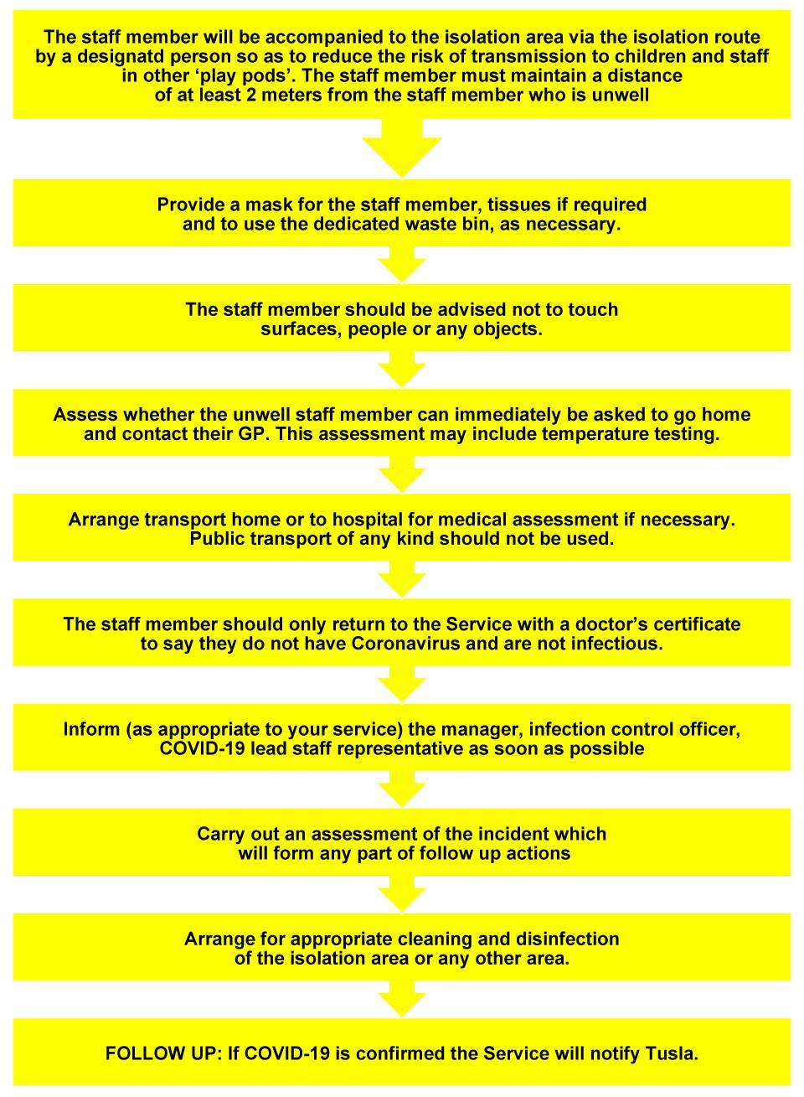

**CHILD**

**If a child becomes unwell and presents as a suspected case**

**of COVID-19 while at the Service**

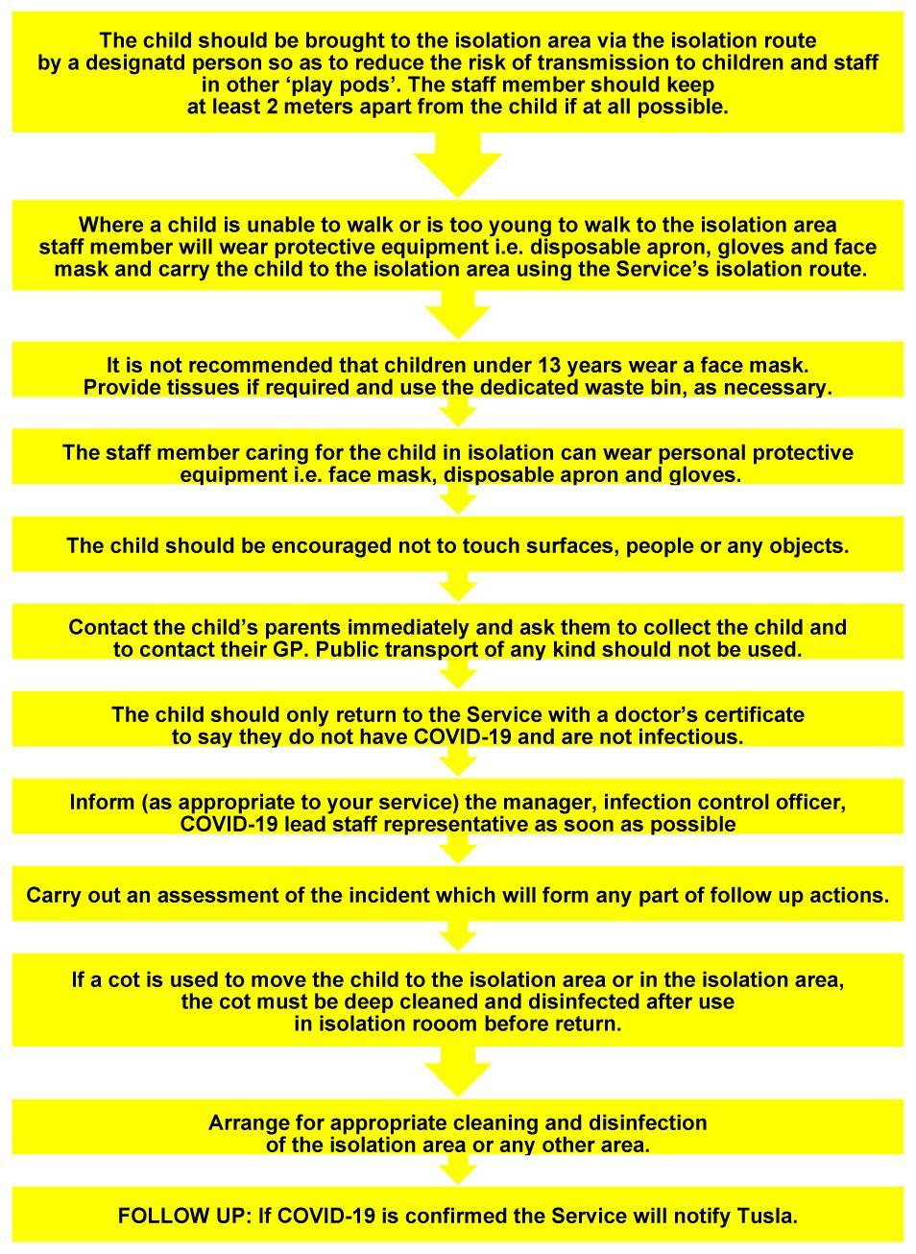

**Temperature testing**

* Scoil Beag routine temperature checking for children is required upon arrival to the service every morning. Temperature testing if a child or a staff member becomes unwell in the service during the day may be required and should be discussed in advance with staff and parents Scoil Beag already have signed agreement on the Temperature checking during the day upon registering your child at Scoil Beag.
* Temperature testing devices will be available in the service as part of standard practice.

**COVID-19 Testing**

* If COVID-19 testing is arranged for a child or staff member by their GP or other medical personnel, the staff member or the parents will be contacted by public health to identify who has been in contact with them. The childcare setting will also be contacted by local public health staff to discuss the case, to identify the close contacts and advise on any actions or precautions that should be taken. It is not necessary to take any action in relation to closing the service, partially or in full until the service has been contacted by and has discussed the case with local public health staff.

**Vaccination**

* It may be recommended by the government that children, staff and parents are encouraged to have the seasonal influenza vaccination this coming winter in order to minimise the risks associated with a possible resurgence of Covid-19 during the annual influenza season. The service will support any such recommendation.

1. **Covid-19 Enhanced Risk Management Policy**

This policy has been reviewed in light of the COVID-19 pandemic and in accordance with HPSC and Tusla’s Early Years Inspectorate Guidance and Information on how to plan for reopening and operating as safely as possible at this time.

Covid-19 is a new illness caused by a new coronavirus (SARA-CoV-2) which is spread mainly through tiny droplets scattered from the mouth or nose of a person with the infection. The droplets can be scattered when the infected person coughs, sneezes, talks or laughs. To infect you, it has to get from an infected person's nose or mouth into your eyes, nose or mouth.

This can happen if

* You come into close contact with someone who has the virus and who is coughing or sneezing
* You touch - with your hands - surfaces or objects that someone who has the virus has coughed or sneezed on, and then touch your mouth, nose or eyes without having washed your hands thoroughly.

COVID-19 is a notifiable disease and must be notified within 3 working days of becoming aware of a notifiable incident. Tusla have developed a Notification Form for COVID-19 which includes additional information regarding the risk of closure as a result of COVID-19. The purpose of this form is to monitor any pending COVID-19 public health issue in early years settings and the continuation of childcare provision.

**Risk management and COVID-19**

In managing the risks associated with COVID-19 in the service, the risk management process outlined in the service’s Risk Management Policy will be used. The risk management approach will focus on identifying the hazards, the level of risk and the controls to address the risks identified. Risk assessment forms will capture the risks identified, the level of risk and the control measures that have been put in place.

**Fire Safety: (GN 5.6)**

Fire evacuation should be carried out per room rather than the entire building during the period of Covid-19.

**Cleaning between Sessions: (GN 6.4)**

* The Service will be cleaned and ventilated between each session.
* The Service will be cleaned thoroughly throughout the day at designated times.

**Daily Risk Assessment**

Daily Risk assessment of classrooms, sanitary areas, sleep areas and outdoorshas been enhanced in light of Covid-19

**Some of the areas of risk that will be included in the risk management process:**

**People**

* Children
* Staff
* Parents
* Visitors / contractors
* People in at risk or in high risk categories
* Pregnant staff
* Staff absenteeism associated with COVID-19

**Activities**

* How staff work together
* How staff and children work together
* The circulation and movement of staff and children in the service
* The drop off and collection of children to and from the service by their parents/carers
* The movement of support staff in the service e.g. cooks, cleaners, administrators, managers
* The engagement of the staff with external contractors, delivery, waste management services

**Environment**

* Spaces – indoor and outdoor including the children’s rooms, outdoor play areas, staff spaces, toilets, kitchen, entrances, reception areas, offices
* Equipment – office, children’s play equipment
* Furniture – staff and children’s furniture
* Toys / books, play materials

1. **Staffing**

**Rosters:** Management will confirm in advance to staff any changes relating to:

* New staff rosters according to pods and to allow for minimum contamination within the pod.
* Starting and finish times
* Rostering of breaks
* Arrangement of teams and how they will work together

Floating/relief people while recognised as essential will be limited as much as possible.

Any changes in staff rosters must be compliant with the adult/child ratios as set out in the Child Care Act 1991 [Early Years Services] Regulations 2016 and the Child Care Act 1991 [Early Years Services] [School Age Childcare] Regulations 2018.

Management will confirm to staff the reason for the changes in rosters, start/finish times and break. These arrangements may change in line with further updates regarding COVID-19 issued by the Government, Public Health Office, DCYA or Tusla, the Child & Family Agency. The arrangements will also depend on how the service reopens and children start attending the service.

**Staff training**

**COVID-19 staff induction training**

Before returning to work all staff will have specific training on the following and a record of this training will be maintained.

* CODIV-19 including symptoms, modes of transmission and how to reduce the risk of transmission of COVID-19
* Revised policies such as infection control, risk management
* The Service’s COVID-19 Incident Plan on the actions to be taken if a staff member or child is suspected as having or tests positive for COVID-19
* The revised procedures for drop off and collection of children
* The revised and enhanced procedures for cleaning
* How to set up the play environment in a play pod and to engage and meet the children’s needs
* How to use personal protective equipment in the event of a child or another staff member becoming unwell

**COVID-19 Lead staff representative[7]**

At least one COVID–19 lead staff representative will be appointed by the employer, to work in partnership with them to assist in the implementation of changes to work practices and infection control measures. The staff taking up this role will receive training. The roles and responsibilities of this individual will include:

* Working collaboratively with employer/manager to ensure that COVID-19 measures are strictly adhered to
* Being aware of the signs, symptoms, transmission of COVID-19 and preventative measures
* Being familiar with what to do if a staff member or a child develops symptoms while in the service
* Being familiar with all the COVID-19 measures in place in the service
* Keeping up to date with government advice on COVID-19
* Supporting effective communication between staff and management on the COVID-19 health and safety measures in place and how they are working
* Being available to staff for any concerns they may have
* Reporting problem areas or non-compliance to management

**Staff breaks**

* Where possible staff breaks/lunches will be covered by staff in the existing pod, however it may be necessary for relief staff to cover breaks. At break times to prevent interaction between staff in different play pods breaks will be done by ensuring social distance of 2 meters between staff at all times. Staff relieving other staff for breaks from another pod will need to wear a visor, PPE and wash their hands regularly while covering breaks in the pod.

**Meetings**

* Conduct meetings as much as possible using online remote means. Where face to face meetings are necessary the length of the meeting should be kept to a minimum and the participants must maintain social distancing of 2 meters at all times.
* Staff members must not gather together in groups in the service or on arrival or when leaving. The service in cooperation with staff will organise the staggering of the movement of staff in and out of the service to support social distancing

**Staff clothing**

* Staff have been given extra uniforms and it is recommended that staff wear a clean uniform each day and, at the end of the day, that staff go home, shower and put uniform or work clothes in the wash immediately at a temperature of 60°.
* If space is available, staff come to work in their personal clothes and change into work wear in work after washing their hands. They should change back into their personal clothes at the end of the day to prevent bringing anything into or home from the service.
* Hands and fingers are free from jewellery and acrylic nails.
* Nails should be cut short and free from polish.

**On-going communication and support**

* This is an uncertain time with many challenges. Public health advice changes as more is known about COVID-19 so the service will provide ongoing support and communication to keep staff up to date.
* We will provide support for staff who may be suffering from anxiety or stress e.g. may have gone through traumatic events such as the serious illness or death of a relative or friend, or be experiencing financial difficulties
* During the COVID-19 period regular ‘check in’ with staff should be carried out by management and/or the COVID-19 representative. Employees should raise any concerns/issues or suggestions.

**Cleaning Facilities**

**Availability Within Our Service:**

|  |  |
| --- | --- |
| **Wash Hand Basins:** | Every Care Room  Every Toilet/ Nappy Changing area  Staff Room  Kitchen |
| **Hand Sanitisers:** | Entrance door outside of Main Building  Entrance door inside  Along the communal corridors on the walls |
| **Storage of Cleaning Agents:** | In a lockable cupboard in each Care Room  Cleaning store in staff area |

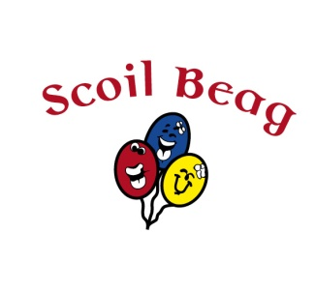

**Parental Declaration Form**

|  |  |
| --- | --- |
| **Childs Name:** | **Manager Name:** |
| **Date of Birth:** | |
| **Parents/Guardians Name:** | |
| **Name of Setting:** | |
| This form is to be used when children are returning to the setting after any absence. | |
| Declaration:  I have no reason to believe that my child has infectious disease and I have followed all medical  and public health guidance with respect to exclusion of my child from childcare services.  Signed ______________________________________  Date: _____________________ | |

1. <https://www.gov.ie/en/publication/22829a-return-to-work-safely-protocol/>
2. <https://first5.gov.ie/practitioners/reopening>
3. <https://www2.hse.ie/wellbeing/how-to-wash-your-hands.html>.
4. <https://www2.hse.ie/conditions/coronavirus/symptoms.html>
5. <http://publichealth.lacounty.gov/acd/docs/COVHomeQuarantine.pdf>
6. <https://www2.hse.ie/conditions/coronavirus/people-at-higher-risk.html>
7. HAS worker_representative_checklist_no_7[16610].docx